THE MATHEMATICIAN AND THE ASTRONOMER

SIMON MARIUS (1573 – 1624)

KATYA Tsvetkova¹, MILAN S. DIMITRIJEVIĆ²,
MILCHO TSVETKOV¹
¹Institute of Mathematics and Informatics, Bulgarian Academy of Sciences
Acad. Georgi Bonchev Str., Block 8, Sofia 1113, Bulgaria
² Astronomical Observatory, Volgina 7, 11060 Belgrade, Serbia
E-mail: katya@skyarchive.org
E-mail: mdimitrijevic@aob.bg.ac.rs
E-mail: tsvetkov@skyarchive.org

Abstract. We present the work of Simon Marius - a mathematician and astronomer who discovered in 1610 the four largest satellites of Jupiter with a Belgian made telescope at about the same time as Galileo Galilei, but published his discoveries 4 years later. In 2014 the astronomical community commemorates 400 years since the publishing of Simon Marius' book Mundus Iovialis containing his observations done independently by Galilei. Marius‘ records are even closer to the modern figures than Galilei's ones. Simon Marius noticed also, that the orbital plane of the Jupiter satellites is slightly tilted relative to both the Jupiter equatorial plane and the ecliptic, explaining thus the discrepancies in latitude, which Galilei did not mention. Marius also noticed the change in the satellites brightness and calculated respective tables for the period 1608 - 1630. Simon Marius was a calendar maker and a translator of Euclid from Greek – he published Die Ersten Sechs Bücher Elementorum Euclidis (The First Six Books Elementorum Euclidis). Among his observations are the comets of 1596 and 1618, the supernova in the constellation Ophiuchus in 1604 (giving its precise position), observations of Venus, and the sun spots, from whose movement he noticed that the equatorial plane of the sun is tilted relative to the ecliptic and the appearance of sunspots is periodical. Simon Marius first observed with telescope the Andromeda Nebula in December 1612, and gave the first description of this object based on telescopic observation.
The multilingual portal dedicated to Simon Marius (http://www.simon-marius.net/) and prepared by the Nuremberg Astronomical Society, has been opened since February 2014. The portal gives introduction to his biography and scientific achievements, as well as retrievable sources, secondary literature, lectures, news and convenient links.

1. Introduction

In 2014 the astronomical community commemorates 400 years since the publishing of Simon Marius' book Mundus Iovialis. The book (Fig. 1) contains his observations in 1609 - 1610 on the four largest satellites of Jupiter with a Belgian made telescope. Marius’s observations had been done at about the same time as Galileo Galilei’s discoveries, but published 4 years later than Galilei. Nowadays the first four satellites of Jupiter are known as the Galilean moons, but their own names - Io, Europa, Ganymede, and Callisto, introduced at the beginning of the 20th century, were given by Simon Marius.

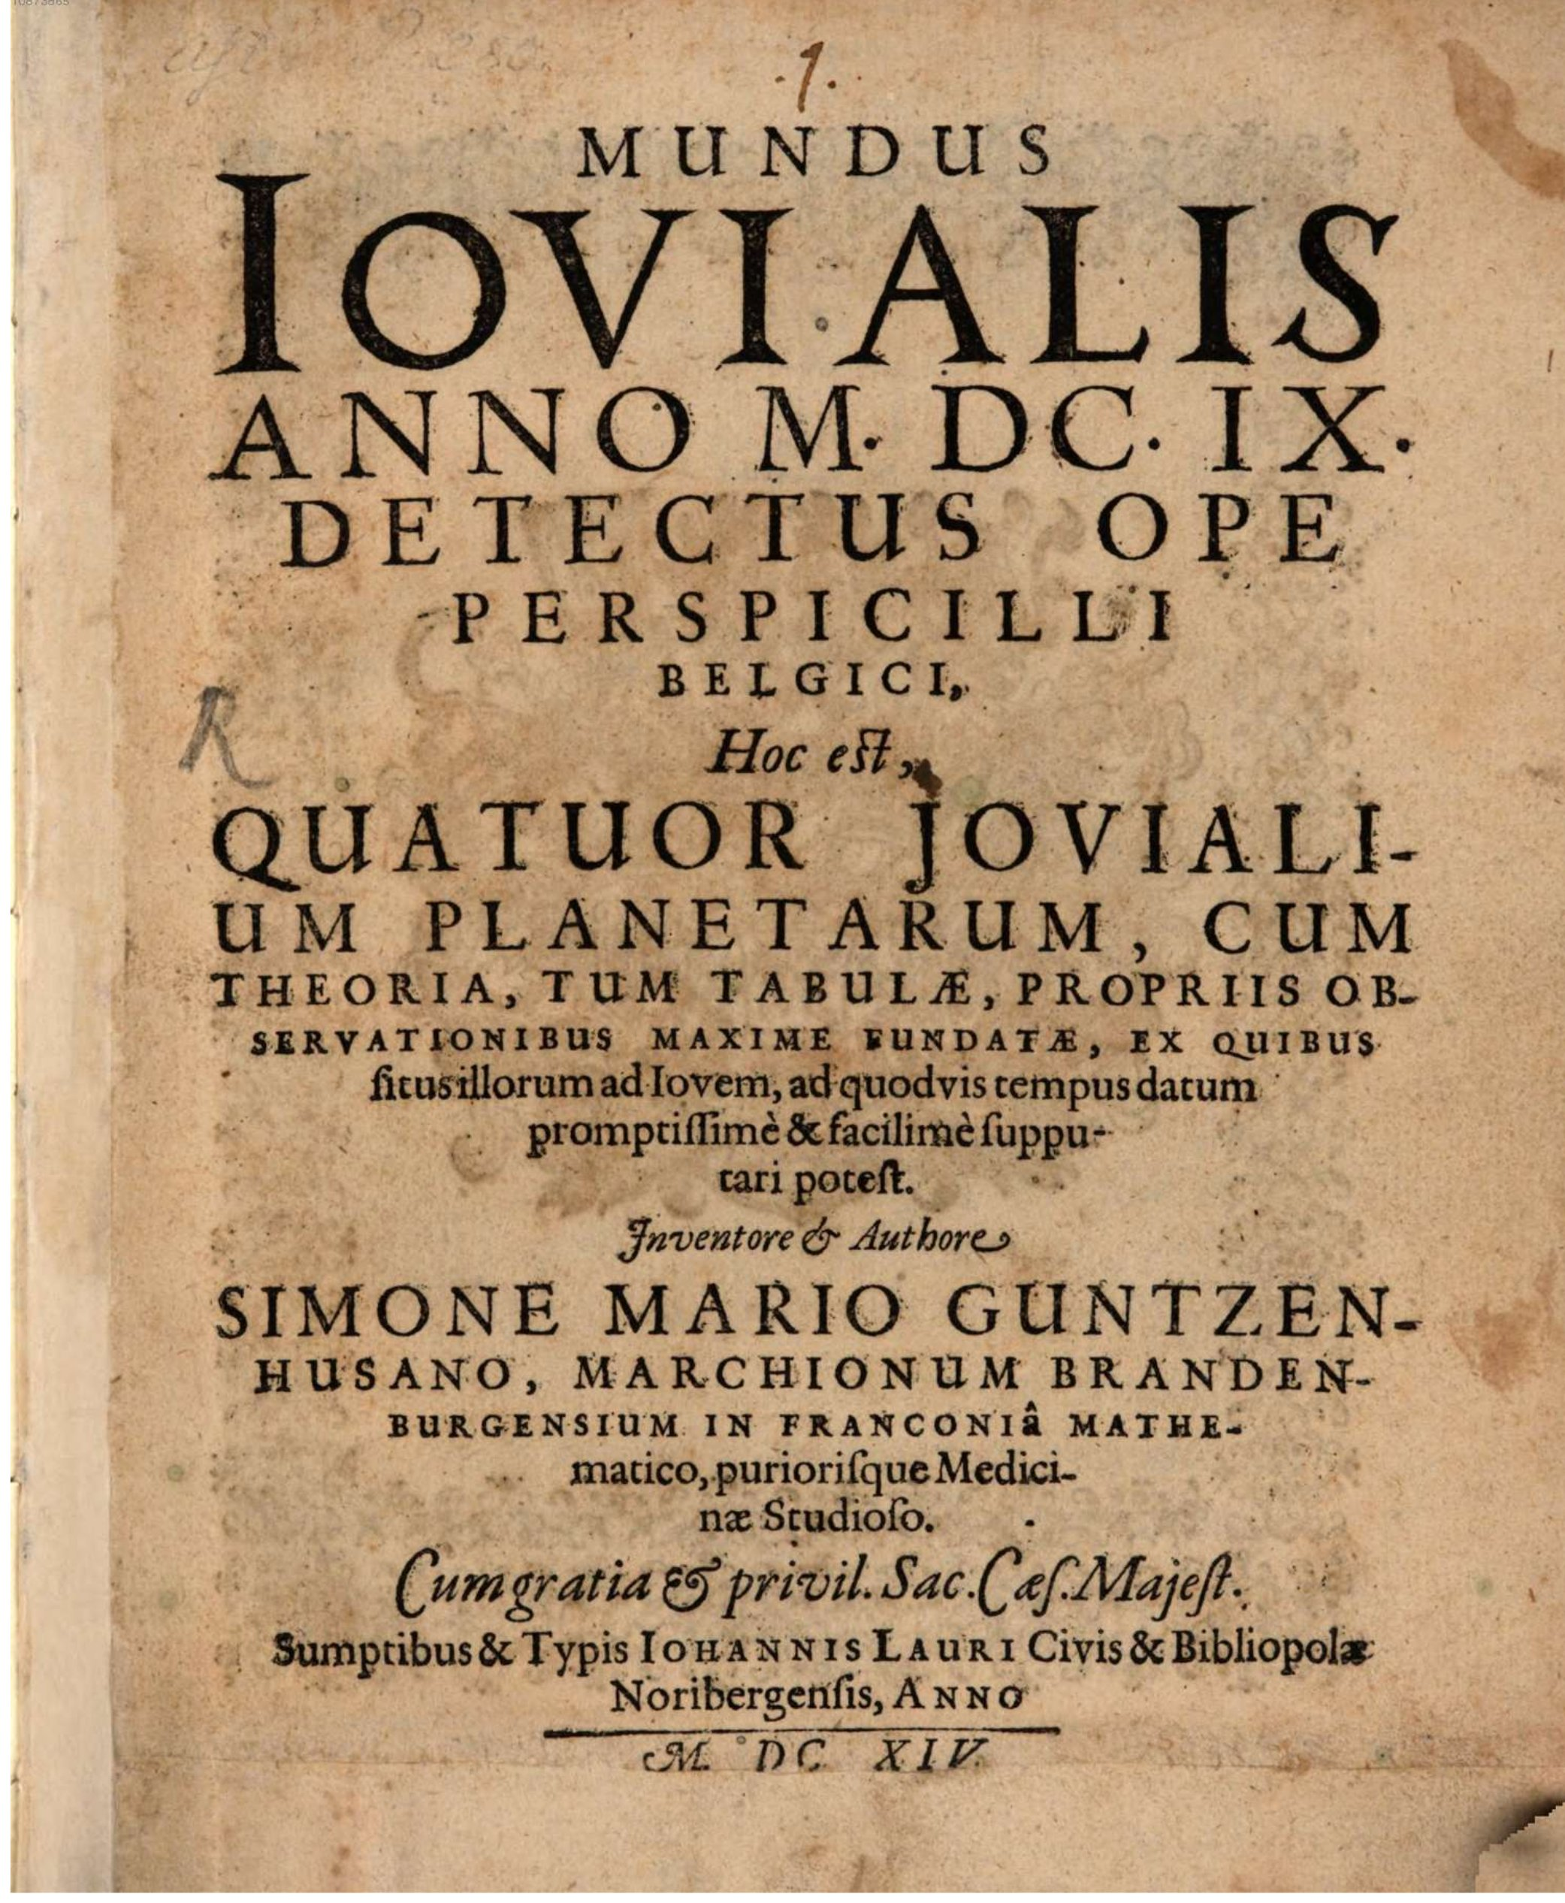

Figure 1. Simon Marius' book Mundus Iovialis from 1614

2. SHORT BIOGRAFY

Simon Marius (Fig. 2) was born on January 10, 1573 as Simon Mayr (or Mair) in Gunzenhausen, where his father Reinhard Marius was a mayor in 1576. By chance the local margrave Georg Friedrich overheard the young Simon singing and arranged for him to be enrolled in the Prince school (Fürstenschule) at Heilsbronn. Simon Mayr finished the school in 1601 and being already interested from astronomy went to Prague to meet Tycho Brahe. But unfortunately Brahe died 4 months later, and Simon continued his education in medicine in Padua in the period 1602 – 1605, being even a member of the board of the so-called German Student-Nation in Padua. In the same time (1592 – 1610) Galilei taught geometry, mechanics, and astronomy in the University of Padua. In the period 1606 - 1624 he was a court mathematician to the Margraves in Ansbach, as well as medical practitioner, astronomer and calendar maker. Meanwhile Simon Mayr married Felicitas Lauer – the daughter of his Nuremberg publisher Johann Lauer, and had five sons and five daughters, of whom only the daughters survived their childhood. Simon Mayr died on January 5, 1625.

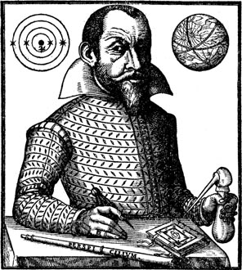

Figure 2. Portrait of Simon Marius from the book Mundus Iovialis

3. Research ACTIVITY

Simon Mayr published as Simon Marius after the fashion of his times. Still being in the Prince school at Heilbronn in 1594 he began his meteorological records, followed by astronomical observations of the appeared comet in 1596, of the supernova in the constellation Ophiuchus in 1604 (giving the precise positions before the invention of the telescope).
Since summer 1609 Simon Marius had at his disposal a Belgian made telescope, thanks to his mentor Johannes Philipp Fuchs von Bimbach. With this telescope he discovered the four largest satellites of Jupiter – by his own records given according to the Julian calendar on December 29, and therefore just one day after Galileo had discovered them, who dated his observations according to the Gregorian calendar. Simon Marius published his discoveries in the book Mundus Iovialis (The World of Jupiter), published by Johann Lauer in Nuremberg in 1614. His observations published in 1614 or 4 years later were done independently by Galilei. Marius‘ records are even closer to the modern figures than Galilei's ones. He noticed also, that the orbital plane of the Jupiter satellites is slightly tilted relative to both the Jupiter equatorial plane and the ecliptic, explaining thus the discrepancies in latitude, which Galilei did not mention. Marius also noticed the change in the satellites’ brightness and calculated respective tables for the period 1608 - 1630.
Marius was also a calendar maker – since 1601 he published yearly the calendars Prognosticon astrologicum up to his dead at end of 1624. Johann Lauer continued to publish the prepared calendars up to 1629.
In 1610 Simon Marius published his translation of Euclid from Greek – Die Ersten Sechs Bücher Elementorum Euclidis (The First Six Books Elementorum Euclidis) published by Paul Böhem in Ansbach in 1610 and containing, 167 pages (Fig. 3).
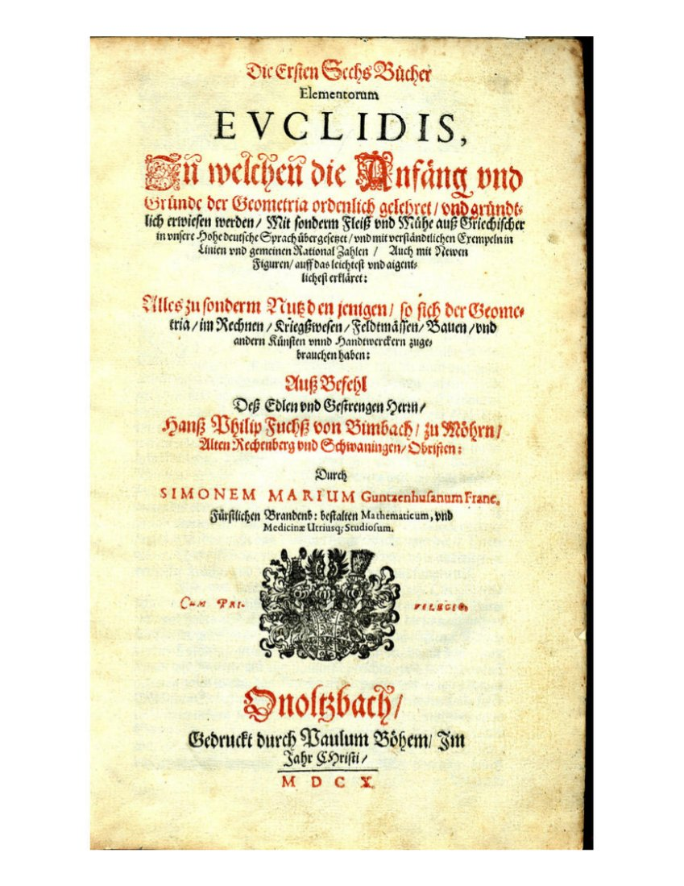

Figure 3. Simon Marius' Die Ersten Sechs Bücher Elementorum Euclidis,
published by Paul Böhem in Ansbach in 1610.

In summer 1611 he did observations of Venus, observations of sun spots since August 1611, from whose movement he noticed in November 1611 that the equatorial plane of the sun is tilted relative to the ecliptic. In 1619 he first suggested that the appearance of sunspots was periodical.
Simon Marius was the first observer with telescope of the Andromeda Nebula in December 1612, and gave the first description of this object based on telescopic observation. The Persian astronomer Abd ar-Rahman as-Sufi (Al Sufi) described the Andromeda galaxy still in 964 according to hand-written parchment. Marius described that this pale gloss observed is not only due of the single stars.
In 1618 Simon Marius observed the third and largest of the three comets of that year.
Although Marius was in the possession of the most important astronomical discoveries of the early 17th century, he opposed the heliocentric world picture and favoured that one of Tycho Brahe after reading Copernicus during the winter of 1595–1596.
To this day, Marius’ work is overshadowed by the Gallilei accusation of plagiarism, even though it was proven at the beginning of the 20th century that Marius had conducted his research entirely independently and even his earliest records are closer to the modern figures than those of Galilei - see the paper Galilee et Marius (from French: Galilei and Marius) of Oudemans and Boscha (1903), ‘Mundus Jovialis’ of Simon Marius - English translation of Mundus Jovialis by Prickard (1916), Zur Ehrenrettung des Simon Marius (from German: In Defense of Simon Marius) by E. Zinner (1942).

4. MULTILINGUAL PORTAL

The multilingual portal (in 28 languages) dedicated to Simon Marius (http://www.simon-marius.net/) and prepared by the Nuremberg Astronomical Society, has been opened since February 2014. It is intended to be a guide through the anniversary year of 2014. The portal gives introduction to his biography and scientific achievements, as well as to electronically retrievable sources, secondary literature, lectures, news, convenient links and announcements for various events
within the framework of the Simon-Marius-Anniversary 2014. Everybody is invited - from the international research community, as well as all other interested people - to make use of this multilingual portal and also to make your own contributions.
Among 28 languages in this multilingual portal are Bulgarian and Serbian. The corresponding portals are prepared by K. Tsvetkova and M. Tsvetkov for the Bulgarian language and M. S. Dimitrijević for the Serbian language.

5. CONCLUSIONS

The intention of this paper is to make the Bulgarian and Serbian astronomical communities known with the scientific achievements of Simon Marius in the anniversary year of 2014. As a scientific acknowledgment of the astronomical community can be assigned the adoption at the beginning of the 20th century of the names of the four largest Jupiter satellites, which were given by Simon Marius. The names are after the lovers of the Greek god Zeus or his Roman equivalent Jupiter – Io (a nymph who was seduced by Zeus), Europa (a Phoenician woman for whom the continent Europe was named, abducted by Zeus in the form of a white bull), Ganymede (a divine hero whose homeland was Troy, described by Homer as the most beautiful of mortals, he was the lover of Zeus, abducted by him in the form of an eagle, to serve as cup-bearer in Olympus), and Callisto (as a follower of Artemis, Callisto, who was the daughter of Lycaon, king of Arcadia, took a vow to remain a virgin, as did all the nymphs of Artemis, but to have her, Zeus disguised himself, as Artemis (Diana), in order to lure her into his embrace). The names were suggested to Marius by Kepler during their meeting in Ratisbon (present Regensburg) in 1613.
In 1935 Simon Marius was honoured by the astronomical community by naming a lunar crater in the Oceanus Procellarum, as well as the nearby “Marius Hills” region (see http://www.rimamarius.com/index.php for more details as “Marius Pit”, etc.). In 1979, a region of ancient dark terrain on Jupiter's satellite Ganymede was named Marius Regio (how it looks like see at http://www. planetary.org/ multimedia/space-images/jupiter/marius-regio-ganymede .html). Recently, in the end of March 2014, the Minor Planet Center announced the decision of the Committee for Small-Body Nomenclature of the International Astronomical Union to give a name of the asteroid 7984, discovered by the Czech astronomer Zdenka Vavrova, after Simon Marius. The minor planet, moving with an average speed of 7.57 km/s, has an orbit of 4.27 years.
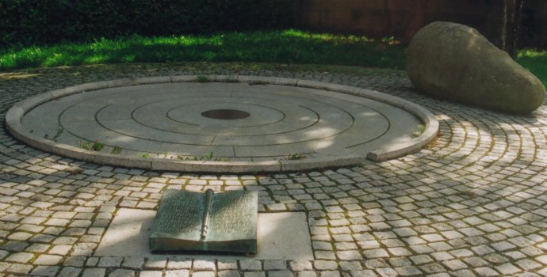

Figure 4. The memorial, commemorating Simon Marius,
designed by Friedrich Schelle and placed in Ansbach in 1991

In 1991 in Ansbach a memorial (Fig. 4), commemorating Simon Marius, was built (it can be seen at http://www.w-volk.de/museum/monum69.htm#bibio00). The memorial, designed by Friedrich Schelle, has a form of a circular flat area with concentric circles, representing the orbits of planet Jupiter and its four largest satellites and an opened book with a telescope separating the two visible pages with a text giving basic information for Simon Marius.

References

Prickard A.O.: 1916, The Observatory, A review of astronomy, 39, 367–381, 403–412, 443–452, 498–503.
Oudemans J.A.C., Boscha J.: 1903, Archives Néerlandaises des Sciences Exactes et Naturelles, Ser. II, T. VIII, La Haye 115–189 (in French).
Zinner E.: 1942, Vierteljahrsschrift der Astronomischen Gesellschaft, 77, Leipzig, 23–75, (in German).

